
Year 7

Forces

What is a force? https://www.bbc.co.uk/bitesize/guides/zttfyrd/revision/1
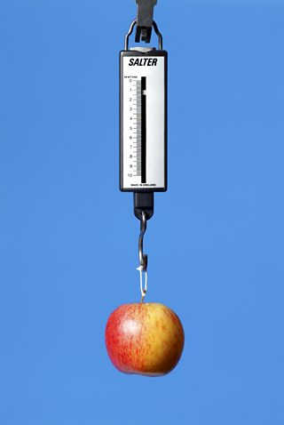
A force can be a push or a pull or a twist (which is really a combo of the two). For example, when you push open a door you have to apply a force to the door. You also have to apply a force to pull open a drawer.
You cannot see a force but often you can see what it does. When a force is exerted on an object, it can change the object’s:
- speed
- direction of movement
- shape (for example, an elastic band gets longer if you pull it)
Forces can be contact forces, where objects must touch each other to exert a force. Some examples are

- Friction
- Air resistance
- Tension
- Compression
- Bouyancy/upthrust
- Applied
- Reaction or normal

Other forces are non-contact forces (or field forces - act via a field, not contact), where objects do not have to touch each other. These include:

- gravity
- magnetism
- static electricity

Measuring forces
Forces can be measured using a force meter, also called a newton meter. Force meters contain a spring connected to a metal hook. The spring stretches when a force is applied to the hook. The bigger the force applied, the longer the spring stretches and the bigger the reading.
The unit of force is called the newton, and it has the symbol N. The greater the force, the bigger the number, so 100 N is a greater force than 5 N.

Forces are scalar quantites
Forces have a strength, which can be represented with a number. For example, a force of 10 N is twice as strong as a force of 5N. Just as important is the direction of the force. For example two 10N forces acting in the opposite direct end up cancelling each other other, but two 10N forces acting in the same direction equal a force of 20N. So forces have both a size and a direction. For this reason Forces are defined as scalar quantities and can be represented as arrows as well as numbers. More on this later.
Questions
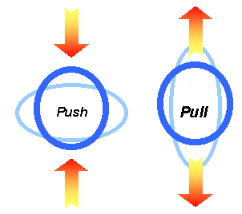
What is a force? ___________________________________________________________
___________________________________________________________
What is the unit of force? _________________________________________________________
Name some types of forces:
_______________________________________________________________________________

_______________________________________________________________________________

What apparatus is used to measure a force? _________________________________________
Contact and non-contact forces

1 Cut out the five pictures and five labels at the bottom of the page.
2 Stick the forces in the correct boxes.
3 Stick the correct label below each picture.

Non-Contact forces
Definition:

Magnetism

Contact forces
Definition:

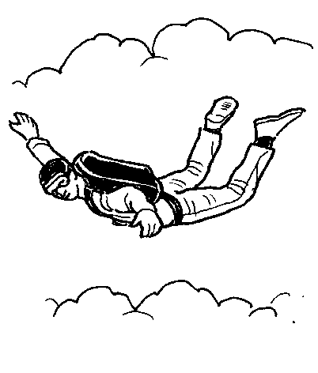 | 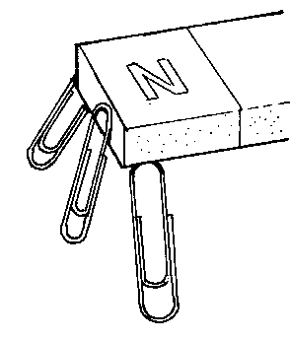 | 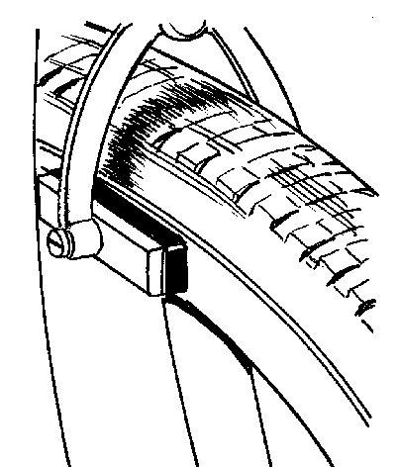 | 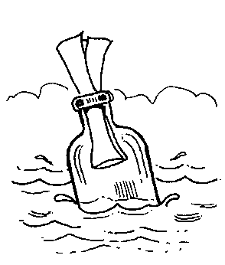 | 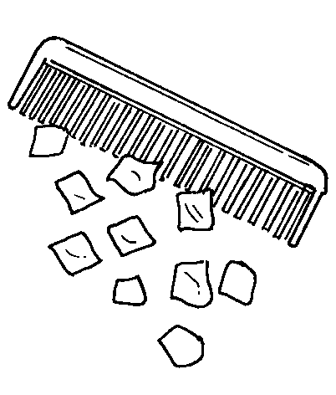

Magnetism | Static  electricity | Friction | Gravity | Upthrust
What is Mass?

Mass is the measure of the amount of matter in an object. Mass is measured in kilograms (kg).

Weight is the amount of gravitational force pulling on an object. Weight is measured in Newtons (N).
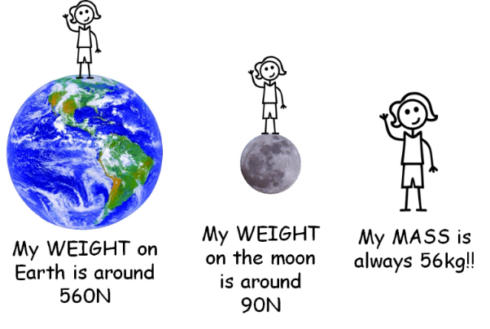
Mass and Weight are different!

Weight can change from place to place (planet to planet), but mass always stays the same.

Experiment to determine the relationship between Mass and Weight.
Aim: To find the relationship between mass and weight
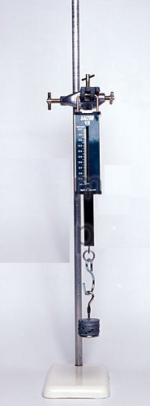
Prediction (What do I think the relationship between the weight and the mass will be?:
Apparatus and Method: Clamp stand, boss, clamp, spring balance, 10 x 100g
- Set up the apparatus as shown in the diagram.
- Make sure that the force meter reads zero, with no mass hung on it. If it doesn’t, speak to your teacher.
- Hang 100g on the force meter (just the base of the stack mass).
- Measure the force on the force meter. Record this in the table.
- Add 100g to the stack mass. Measure the new force on the force meter.
- Record this in the table.
- Keep adding and measuring until you have 1kg hanging. Repeat the experiment once and get an average of your results.
- Record your final force measurement. (1kg = 1000g) Thus to convert from g to kg, divide your mass in grams by 1000.
Variables (a quantity that changes):
Independent Variable (the one I change): __________________________
Dependent variable (the one that changes as the independent variable changes): ____________________
Controlled Variables (the one that remain the same through the experiment):
_______________________________________________________________________________________

Now complete the experiment and add your data to the table below:

Table 1 – mass and weight
Mass  (g) | Mass  (kg) | Trial 1 | Trial 2 | Trial 3 | Average Weight  (N)
Mass  (g) | Mass  (kg) | Weight  (N) | Weight  (N) | Weight  (N) | Average Weight  (N)

Graph: Plot the graph with the dependent variable (Average weight - Y-axis) plotted against the independent variable (Mass in kg - X-axis) and draw a line of best fit.
Tips for drawing the graph:
- Ensure that your graph has a heading
- Label each axis with a title and a unit
- Choose a suitable scale that will ensure that the graph takes up over half of the graph paper
- Mark off your points on the graph with a small cross using a pencil
- Draw a smooth line that passes close to most of the points (line of best fit) – this graph will be a straight line

Conclusions (What relationship did you discover between mass and weight?)

_____________________________________________________________________________________

_____________________________________________________________________________________

$$Weight=mass×a constant value \left(gravitational acceleration\right)$$

$$Weight=mass×g$$
$$W(N)=m(kg)×$$

Questions:
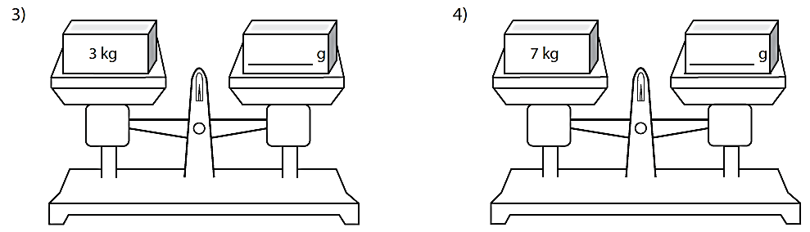
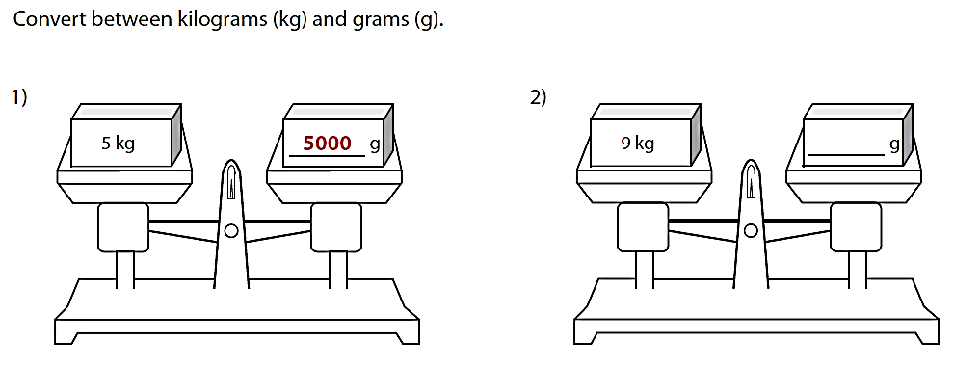
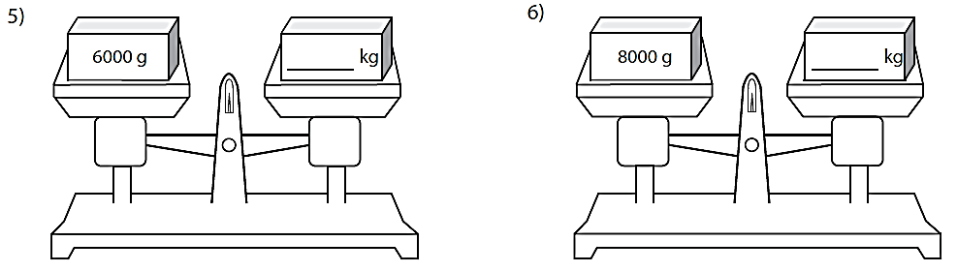
Mass and mass coversions
Q7 What would be the weight of? Remember to convert your mass to kilograms first.
- 120g
- 45kg
- 20g
- 760g

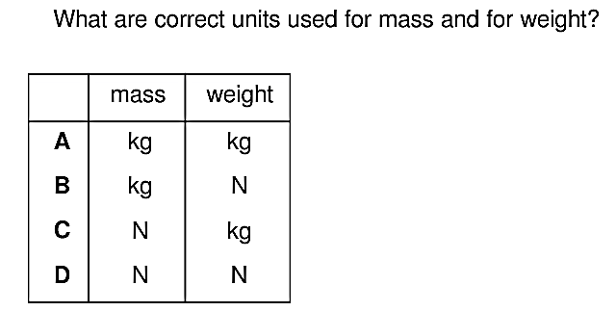
Q8
Question 9
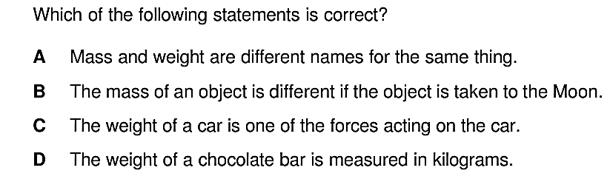

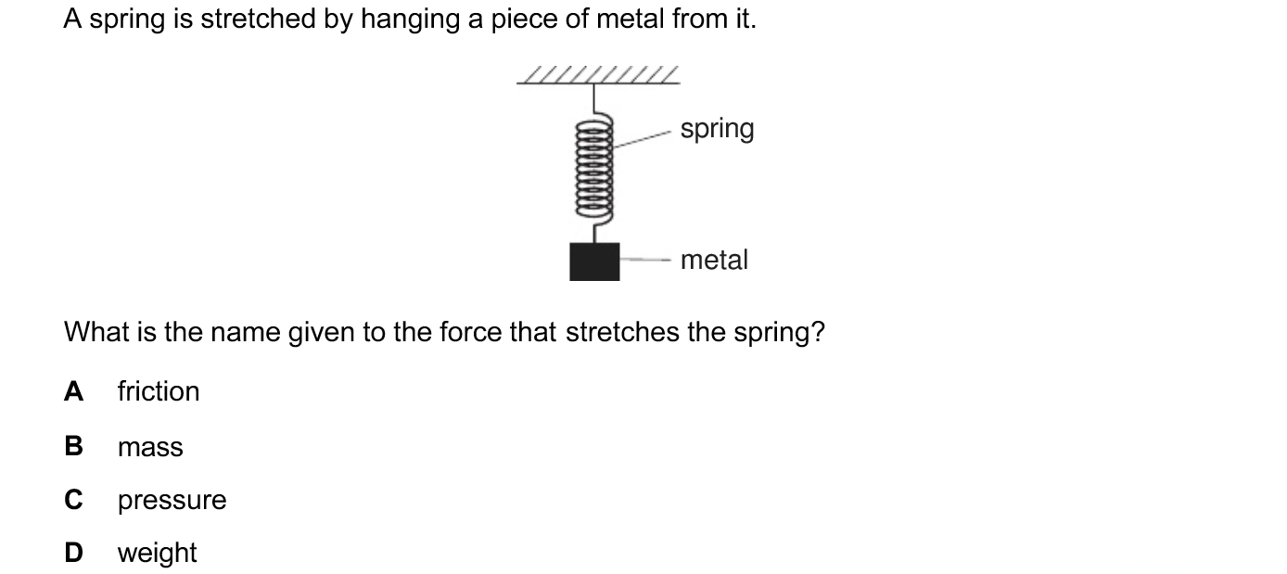
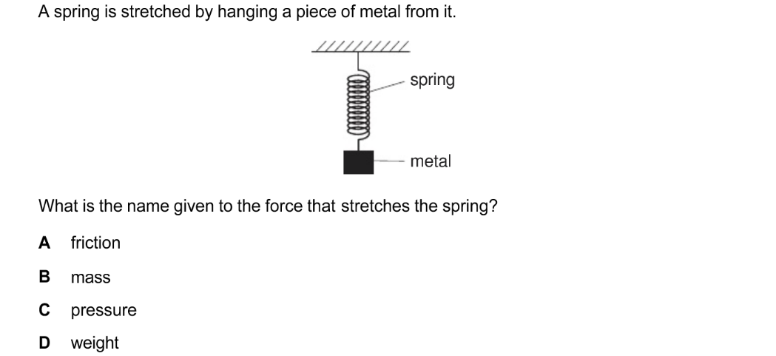
Q10 Q11
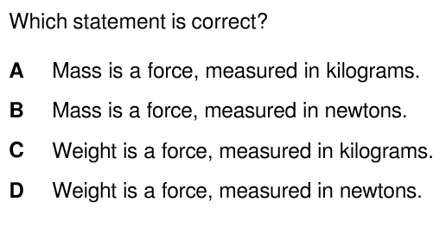

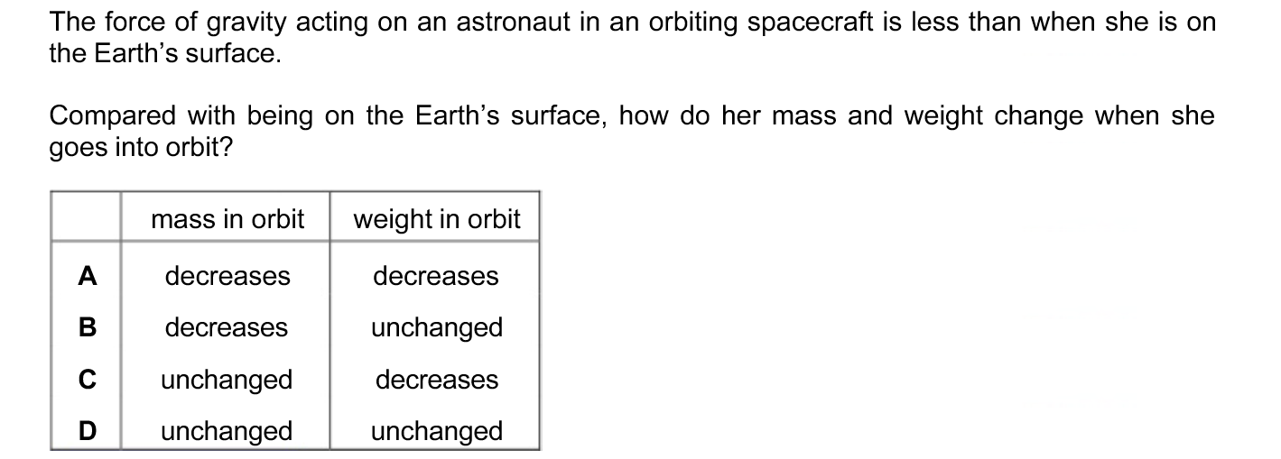
Q12

Observing Forces Experiment

Go to the experiment that you have been assigned to. You will have 3 minutes per experiment in order to complete all the tasks set and answer the questions.

WARNING:
Do not touch the apparatus until you fully understand what you need to do. Follow the instructions on this work sheet. Do not attempt to try anything you have not been told to try, you may damage the equipment and hurt yourself in the process.
If you suspect that the experiment is not working, tell the teacher. Do not attempt to fix it yourself.
 | No. |  | Instructions | Results
 | 1 |  | Pick up the lump of plasticene. Give it a squeeze.  - What do you notice happens to the lump of plasticene?  Place the plasticene on the bench. Press down with your knuckles.  - What happens?  - What does this tell about the effect that forces can have on objects?  Make the plasticene into a ball when you have finished. | 1. _______________________________________  2. _______________________________________  _________________________________________  3. _______________________________________  _________________________________________
 | 2 |  | DO NOT TOUCH THE TOP PAN BALANCE.  - What is the reading on the top pan balance?  Hold the bar magnet about 1cm above the bit of metal on the balance.  - What is the new reading on the balance?  - What seems to have happened to the weight of the piece of metal?  - What force is acting to do this?  - What happens to this force if the magnet is brought closer to the metal? | 1. _______________________________________  2. _______________________________________  3. _______________________________________  4. _______________________________________  5. _______________________________________
 | 3 |  | Switch on the air track blower. DO NOT PUT YOUR FACE IN FRONT OF THE NOZZLE. Place the ball in the air stream above the nozzle.  - What do you notice about the apparent weight of the ball?  Try to balance the ball in the air stream.  - What 2 forces are acting on the ball?  - What can you say about the forces acting on the ball, if it is balanced?  - What would happen if the ball were lighter? Why?  Switch off the blower and put the ball back. | 1. _______________________________________  2. _______________________________________  3. _______________________________________  4. _______________________________________  _________________________________________
 | 4 | Put car A at the top of the slope. Release it.  - What force was making the car move when it was on the slope?  - Why did the car slow down, as it ran along the bench?  Try the same experiment with car B.  - What do you notice?  - Why do you think this car was different? Push both cars gently along the bench.  - What is the difference between the 2?  - What does this tell you? |  |  | 1. _______________________________________  2. _______________________________________  3. _______________________________________  4. _______________________________________  5. _______________________________________  6. _______________________________________
 | 5 | Place a bit of spaghetti on the 2 blocks, so that it makes a bridge. Hang the base of the stack mass on the middle of the spaghetti.  - What do you notice?  Add a few masses to the hanger.  - What do you notice, as you add the masses?  - What force is acting on the spaghetti?  - As you keep adding the masses, what happens eventually?  - What does this tell you?  - What would happen if you were to use 2 bits of spaghetti (don’t do it)? |  |  | 1. _______________________________________  2. _______________________________________  3. _______________________________________  4. _______________________________________  5. _______________________________________  6. _______________________________________  _________________________________________

WORDSEARCH - Write the answers to the clues in the spaces.

Clues Answers
W | F | R | I | C | T | I | O | N
S | R | A | O | P | D | Y | Q | L
A | F | C | H | R | T | Y | U | M
S | T | E | O | I | U | F | S | J
I | S | I | V | N | P | I | T | P
D | V | A | R | E | T | I | O | M
B | R | N | I | E | H | A | I | E
G | I | K | N | O | R | U | C | L
R | C | G | D | I | U | E | M | T
S | A | I | B | O | S | K | F | U
M | F | S | T | A | T | I | C | Z

A force which pulls you down. ____________________

This force helps to hold things to fridge doors.____________________

This type of force needs to touch something to affect it._______________

This force rubs things away. ____________________

This force helps a ship float. ____________________

A form of electricity which can attract things.____________________

Now try to find the words in the wordsearch.
Mark all the contact forces in red and the non-contact forces in blue.
(Use pen and pencil if you do not have any coloured pencils.)

Springs and Hooke’s Law
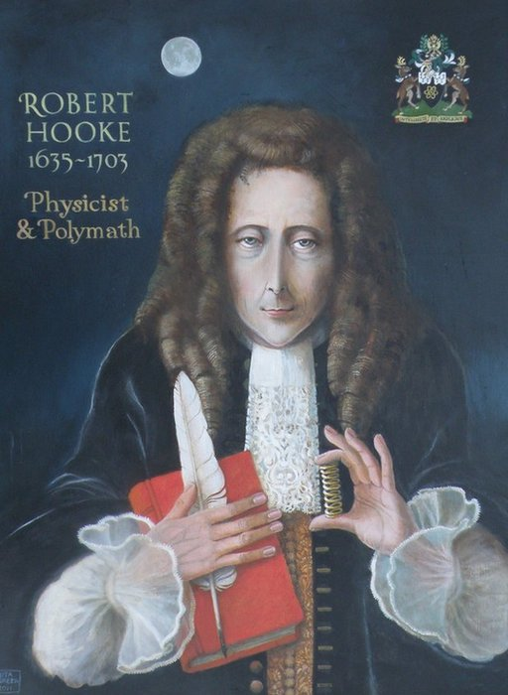
Hooke’s Law was named after Robert Hooke, an English physicist, considered the greatest mechanic of his age. He made many improvements in astronomical instruments and in watches and clocks. He invented the spiral spring in watches and constructed the first arithmetical machine.
The law states that under appropriate conditions, if you apply a weight of $"F" units$ to a spring, that spring will stretch$"x" units$. Further, F will be directly proportional to x, that is to say
$$F=k×x$$
where k represents the spring constant or stiffness.
The spring constant or stiffness of the spring depends on factors such as spring thickness, and the materials used in its composition.
When the spring has no weight on it, and it is in its natural resting position, the spring is said to be at equilibrium. When force is applied, such as weight, and the spring stretches, this is known as displacement. In this experiment you will collect data to discover the spring constant for a spring.
In the formula $F=kx$, k is the spring constant.
Stretching Spring Experiment
Aim
To find the relationship between the force exerted on a spring and the extension of the spring.
Prediction (What do I think the relationship between the Force (weight) and the extension will be?):
_______________________________________________________________________________________
_______________________________________________________________________________________
Apparatus and Method Wear your eye protection!
h
Clamp stand, clamp, spring, 100g slotted mass hanger,
9 X 100g slotted masses, Metre ruler
- Arrange a clamp stand to hold a spring as illustrated in the picture
- Measure, and record the height (h) between the bottom of the spring and the base of the clamp stand.
- Hang an empty slotted mass hanger on the end of the spring and measure and record h on your table
- Take a series of height measurements as the slotted masses are added to the hanger, increasing the stretching force.
- Repeat the whole experiment one further time and calculate the average height
- Using the original height of the spring and the new average heights measured after adding the masses, calculate the extension of the spring, each time an extra mass is added.
- Hang the wooden block of unknown mass from the spring and measure the height. Add this information to the bottom of your table – do not add it to your graph. We will use it in the next lesson
- Plot a graph of Stretching force in Newtons (N) (y-axis) against extension distance in metres (m) (x-axis)of your results
Variables (a quantity that changes):
Independent Variable (the one I change): ________________________________
Dependent variable (the one that changes as the independent variable changes): ____________________
Controlled Variable (the one that must remain the same throughout the experiment):
_______________________________________________________________________________________
Results
Before masses are added to the spring: Height (m) = ______________________
Mass  (g) | Mass (kg) | Force (N) | Height 1 (m) | Height 2 (m) | Average Height (m) | Extension (m) | Force  Extension  (N/m)
Note:
- To convert from g to kg, divide the mass in grams by 1000
- To convert from cm to m, divide the height in cm by 100
- To calculate the force exerted by the mass hanger: Force (N) = mass (kg) X 10
- Ensure that your average height has the same number of decimal places as each of the heights measured
- To calculate the extension, subtract the average height from the starting height
Graph: Plot the graph with Force (Y-axis) against extension (X-axis) and draw a line of best fit. Stick the graph below. For this graph we will plot the independent variable on the Y-axis and the dependent variable on the X-axis.

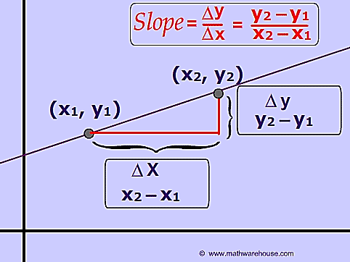
Analysis
In this experiment we will try to discover the value of the gradient or slope of the graph.
How to find the gradient of a straight line:
The formula on the right hand diagram is the correct way to calculate the slope of the line, but it looks a little confusing, so let’s learn through an example. Look at the line shown in the example below, on the right.

STEPS: to calculate the slope (gradient) of a line:
- Choose any two points on the line of best fit as far away from each other as possible. Put a cross there.
- Label the left point as (x₁, y₁) and the point on the right as (x₂, y₂)
- Also label each point with its correct x and y values. In the example the y axis is large so the y values are quite big compared to the x values
Change
in Y
Change in X
X
X
(x₁, y₁)
(x₂, y₂)
(2, 25)
(7, 70)
50 -
5
l
- Use the formula $Slope= \frac{Change in y}{Change in x}=\frac{y_{2}- y_{1}}{x_{2}- x_{1}}$ to calculate the slope.

In the example on the right this would look like:
$Slope= \frac{Change in y}{Change in x} = \frac{70- 25}{7- 2} = \frac{45}{5} = 9$
$Slope= 9$

Now look at the graph you have drawn for your experiment and follow the instructions on the previous page to find the slope or gradient of the graph.

This gradient is also known as the spring constant (k) and is an indication of how stiff a spring is.

$$Force=spring constant×extension$$

Conclusion
What relationship did you discover between the force and extension of the spring? Describe the relationship in words, justify the relationship by referring to data, and state the relationship mathematically if you can.

_______________________________________________________________________________________
_______________________________________________________________________________________
_______________________________________________________________________________________
______________________________________________________________________________________________________________________________________________________________________________
_______________________________________________________________________________________

Evaluation (Identify the amount of error you believe was in the experiment, justify by referring to the data, and identify reasons these error occurred. Extension – identify your errors as random or systematic)

_______________________________________________________________________________________
_______________________________________________________________________________________
_______________________________________________________________________________________
_______________________________________________________________________________________
_______________________________________________________________________________________
_______________________________________________________________________________________
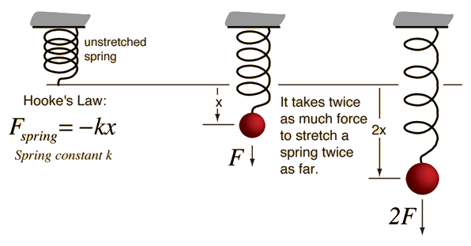
_____________________________________________________ ______________________________________________________ ____________________________________________________ ____________________________________________________
EXTENSION – the following experiment is similar to the one above, but using a rubber band rather than a spring. There are less instructions with this experiment as it can be done in a similar way to the experiment above. The results you obtain may or may not be the same – it will depend on whether rubber bands obey Hooke’s Law.

Hooke’s Law: Elastic Band Practical
Aim
To find the relationship between the force exerted on an elastic band and the extension of the elastic band and in doing so identify if rubber bands obey Hooke’s Law.
Prediction (What do I think the relationship between the Force (weight) and the extension will be?):
_______________________________________________________________________________________
_______________________________________________________________________________________
Results
Before masses are added to the spring: Height (m) = ______________________
Mass  (g) | Mass (kg) | Force (N) | Height 1 (m) | Height 2 (m) | Average Height (m) | Extension (m) | Force  Extension  (N/m)
Note:
- To convert from g to kg, divide the mass in grams by 1000
- To convert from cm to m, divide the height in cm by 100
- To calculate the force exerted by the mass hanger: Force (N) = mass (kg) X 10
- Ensure that your average height has the same number of decimal places as each of the heights measured
- To calculate the extension, subtract the average height from the starting height
Graph: Plot the graph with Force (Y-axis) against extension (X-axis) and draw a line of best fit. Stick the graph below. For this graph we will plot the independent variable on the Y-axis and the dependent variable on the X-axis.

Conclusion
What relationship did you discover between the force and extension of the spring? Describe the relationship in words, justify the relationship by referring to data, and state the relationship mathematically if you can.

_______________________________________________________________________________________
_______________________________________________________________________________________
_______________________________________________________________________________________
_______________________________________________________________________________________
_______________________________________________________________________________________
_______________________________________________________________________________________

Evaluation (Identify the amount of error you believe was in the experiment, justify by referring to the data, and identify reasons these error occurred. Extension – identify your errors as random or systematic)

_______________________________________________________________________________________
_______________________________________________________________________________________
_______________________________________________________________________________________
_______________________________________________________________________________________
_______________________________________________________________________________________
_______________________________________________________________________________________

